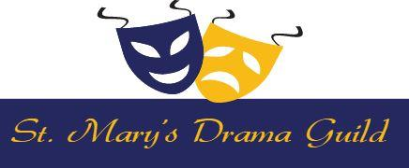  Website: www.stmarysdramaguild.org  Celebrating our 75th Season  Founded By Lindo Meli- 1949  Rev. Christopher O’Connor, Pastor Claire Spinetti, Director | 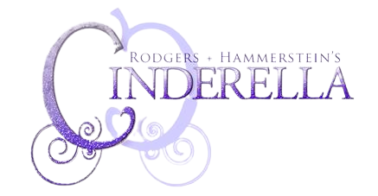  Music by Richard Rodgers  Lyrics by Oscar Hammerstein II  New Book by Douglas Carter Beane  Original Book by Oscar Hammerstein II  Cinderella is presented by arrangement with Concord Theatricals on behalf of  The Rodgers & Hammerstein Organization. www.concordtheatricals.com

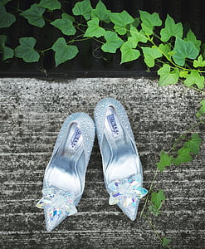  Commerical Ad Form Only  ***** RETURN ASAP *****  DEADLINE:  Sunday, April 7th  ~~~~~~~~~~~~~~~~~~~~~~~~~~~  *** Donations are tax deductible ***  Send email to: stmarysdramaguild@gmail.com  (preferable) or drop off at the rectory with check, cash or money order PAYABLE TO ST. MARY’S CHURCH in an envelope marked “Drama Guild – Playbill.”  To download this form, for further information or to send an email, please visit our website www.stmarysdramaguild.org or on Facebook “StMarys Drama Guild” or Call the rectory at 718-672-4848. | Commercial Ads (businesses):  Full Page Ad …………………….$100.00  Half Page Ad …………………….$ 75.00  Quarter Page Ad ………………...$ 40.00  Back Covers (Request Information)  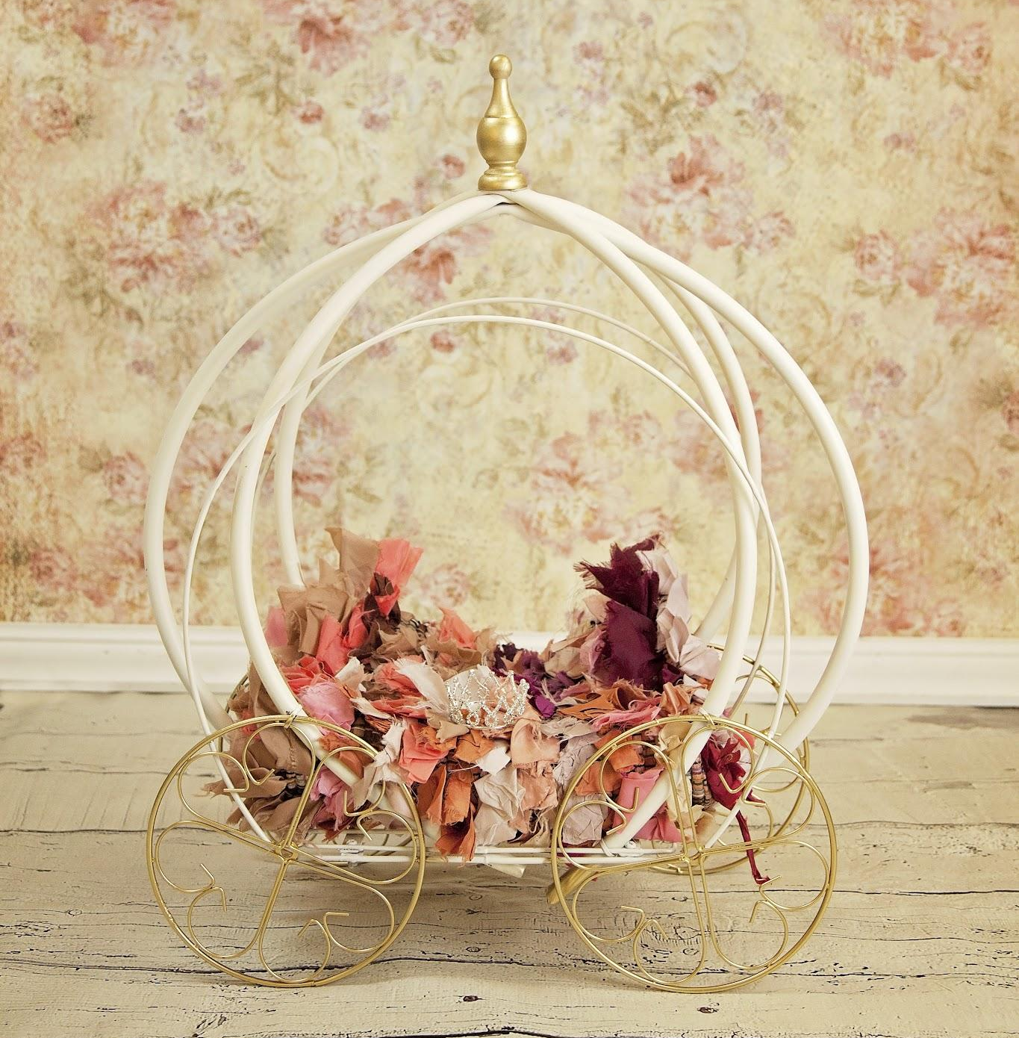
DATES: Saturday, April 27th & May 4th & Sunday, April 28th & May 5th
Name (print):
Company Name:
Email:
Address:
City, State & Zip: | Phone:
Check Amount Enclosed: $ | Ad Size:
CHECK ALL THAT APPLY:
☐ Personal message is attached → | ☐ I have sent an email to stmarysdramaguild@gmail.com
☐ St. Mary’s Drama Guild can make a message | ☐ Congratulations Cast & Crew

